**Advanced Defense and Countermeasures Lab**

1.5 Assignment Packet Capture and Analysis in Palo Alto Firewalls

**Student’s Name: - Nazir S. Terrell Date: - 3/6/2025**

rb_drop

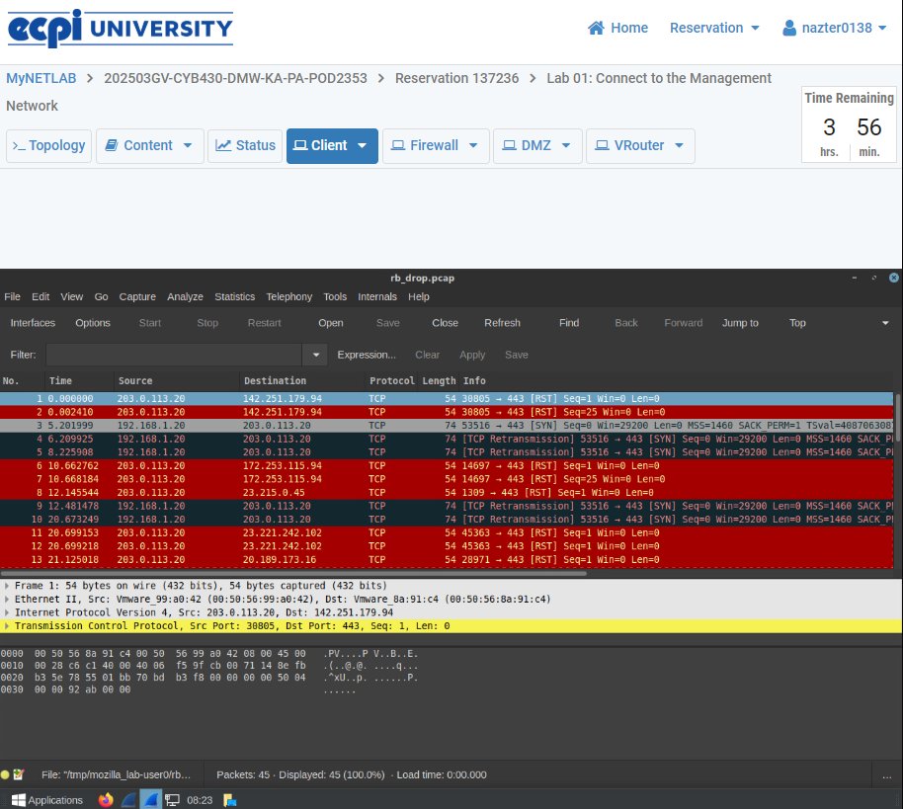

rb_firewall

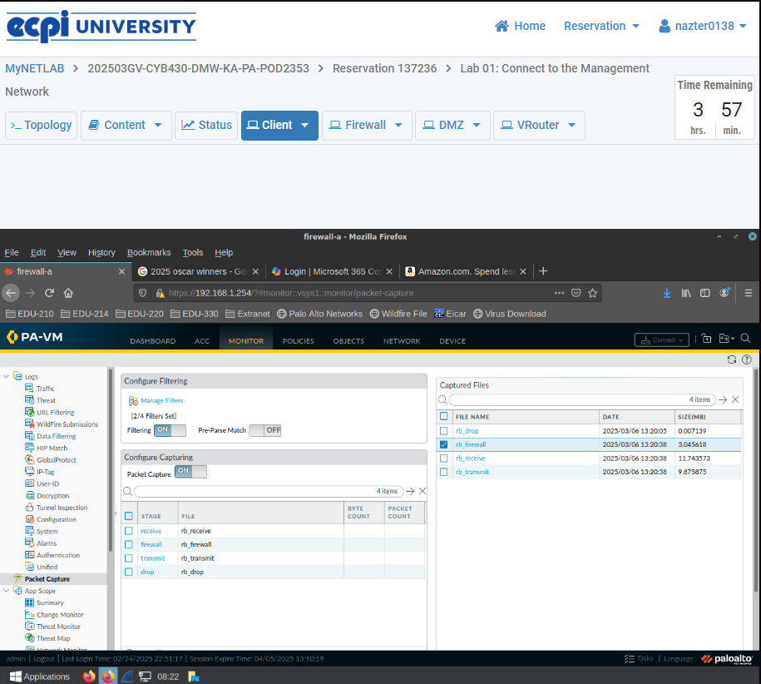

rb_recieve

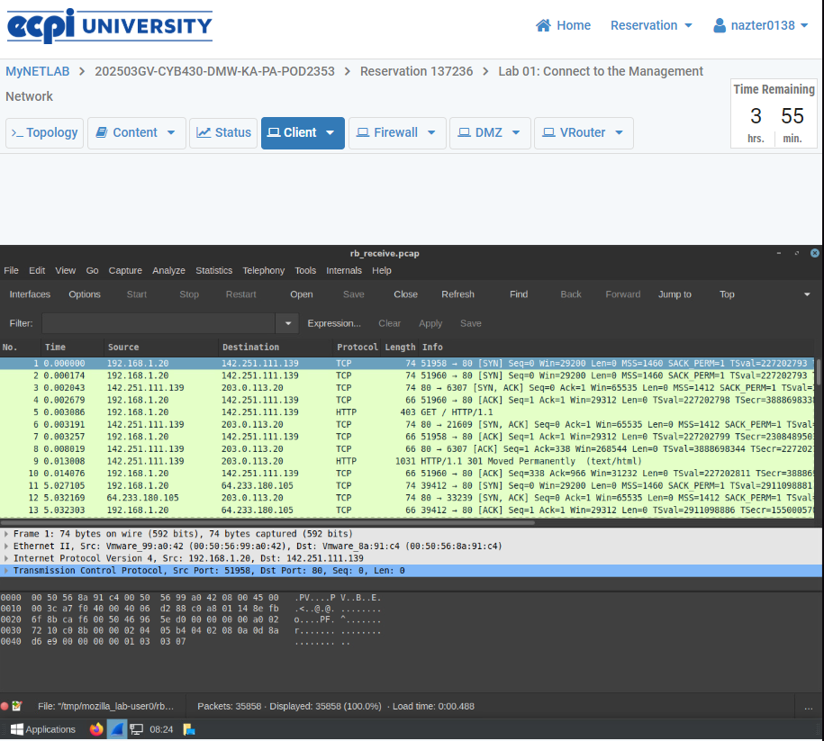

rb_transmit

